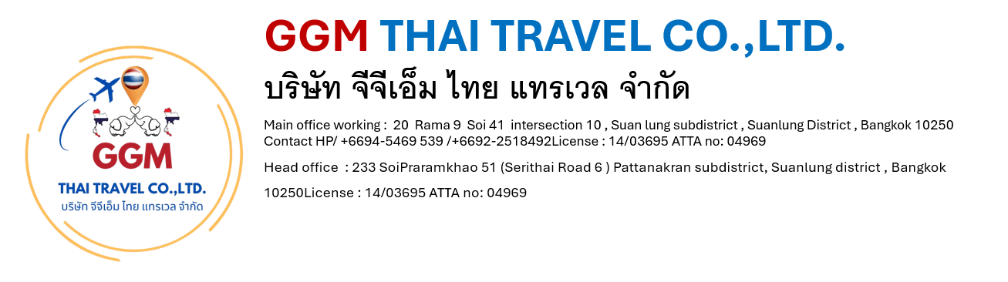

Chiang Mai 4 Days/3 Nights

Tour Highlights: Old City & City Gate / Chedi Luang Temple / Phrasing Temple / Kantoke Dinner / Elephant Sanctuary / Wat Phrathat Doi Suthep / Doi Inthanon National Park / Chiang Mai Home Industries
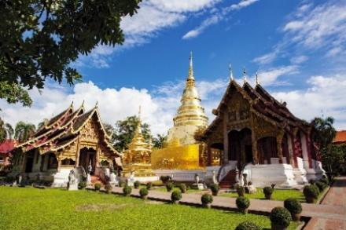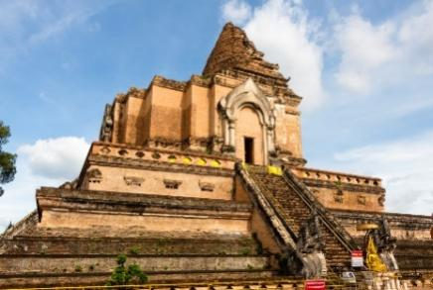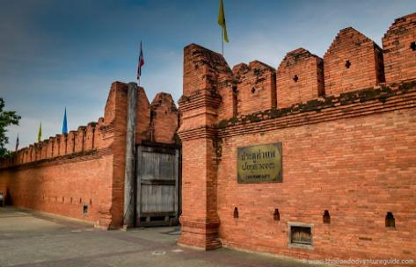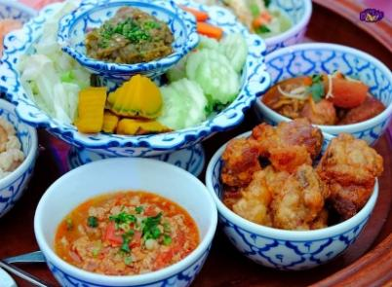

Day 1: Arrival Day - City Tour – Kantoke Dinner (-/-/D)
• Morning / Afternoon - Warmly welcome at Chiang Mai Airport
• City Tour around the old city of Chiang Mai where's surrounded by the ancient wall.
• Visit Phra Sing Temple, Chedi Luang Temple and Tha Pae Gate
• 18.00 - 20.30 pm. Have a Kantoke Dinner with a Northern Thai food dinner and Thai tradition dancing performance at Khum Kantoke Restaurant
• Transfer to check in at hotel in Chiang Mai town, free and easy.

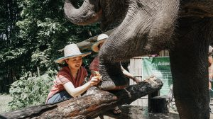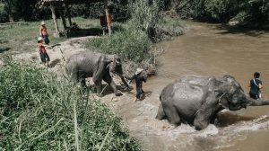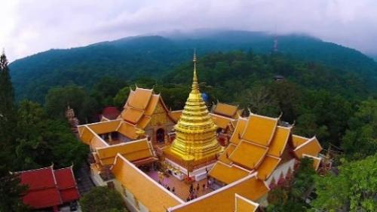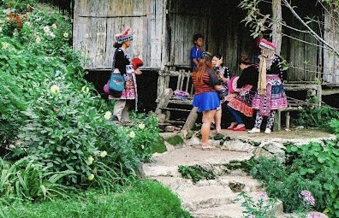

Day 2: Doi Suthep Temple - Elephants Care (B/L/D)
• 09.00 am. Pickup at hotel and departure to the north route of Chiang Mai to Mae Rim district
• 09.45 am. Visit to Mae Rim Elephant Home to enjoy with 2 hours Elephants Care (Learning, Elephant Foot Care, Walking with elephants, Feeding, Mud Bathing, Bathing in the river)
• 12.00 pm. Have a local lunch with Pad Thai and fresh fruits
• Afternoon, Drive up to the mountain to visit Doi Suthep Temple, the most important temple in Chiangmai with an impressive city view.
• Visit Hmong Doi-Pui Hilltribe Village
• 17.30 pm. Have a dinner at local restaurant
• 19.00 pm. Transfers to hotel, free and easy.

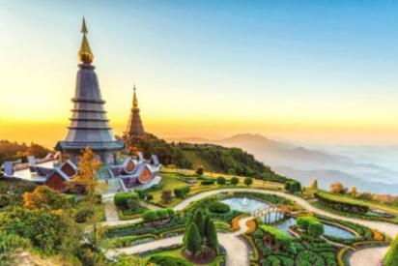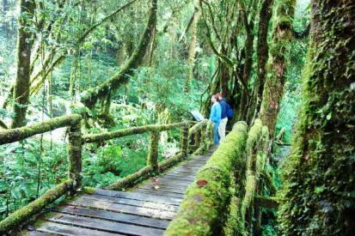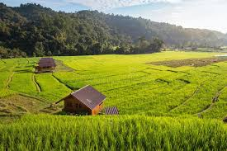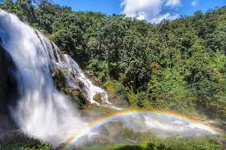
Day 3: Doi Inthanon National Park (B/L/D)
• 08.30 am. Pick up at hotel.
• Visit Doi Inthanon National Park, the highest peak mountain of Thailand.
• Take an easy walking on Angka Nature Trail
• Visit Twin Royal Pagodas
• 12.00 pm. Lunch at local restaurant
• Visit Hilltribe Market
• Visit Ban Mae Klang Luang Karen Hillribe Village with coffee tasting
• Visit Wachiratharn Waterfall
• 16.00 pm. Back to Hotel in town and have a dinner at local restaurant
• 19.00 pm. Transfers to hotel

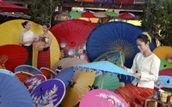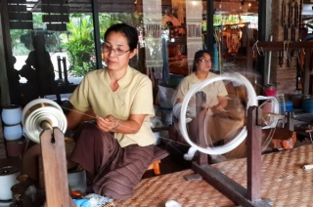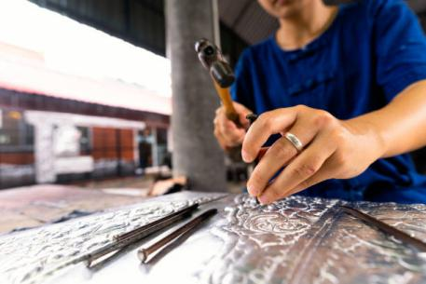

Day 4 : Home Industries - Departure Day (B/L/-)
• 09.00 am. Pick up at hotel.
• Visit San Kampeang Handicraft Village is well known of hand made product such as umbrella making, silver ware, lacquer ware, Thai silk, gems stone and wood carving.
• 12.00 pm. Lunch at local restaurant
• Afternoon – Transfers to Chiang Mai Airport (Depends on the flight.)

